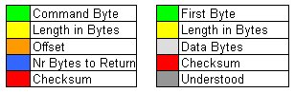  
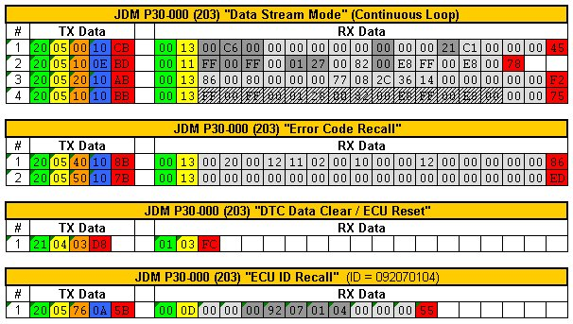  
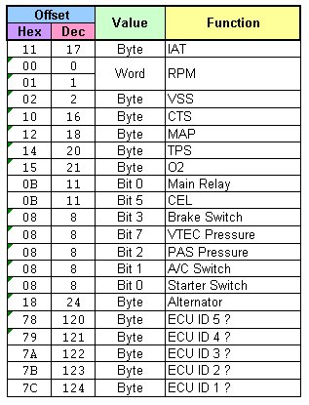

**Quote (Renemen @ 25.10.11 - 13:56) [*](http://hondamotor.ru/board/index.php?act=findpost&pid=1881079)**

**OBD II**  
To translate the ECU out of the standard ISO protocol 9141 in the native protocol HONDA necessary to send the command:   
68 6A F5 AF BF B3 B2 C1 DB B3 E9 Then, almost immediately (200-300 ms), you can send requests HOBD, and initialization of the ISO 9141, usually not required.

I forgot to add that after the request has to come back. I think that this is important: 0000000000: Open COM1 Baud = 10400 RTO = 20 0000003074: TxD (Echo): 68 6A F5 AF BF B3 B2 C1 DB B3 E9 0000003074: RxD: 48 6B 10 EF B2 0000003074: 5Baud Addr = 33 KW1 = 08 KW2 = 08 0000003074: 5Baud Init OK 0000003120: TxD (Echo): 20 05 00 09 D2 0000003120: RxD: 00 0C 13 96 04 00 00 00 00 00 84 C3 0000003167: TxD (Echo): May 20 0B 0D C3 0000003167: RxD: 00 10 41 04 01 00 00 37 62 53 90 2A 4D 00 92 250000003199: TxD (Echo): May 20 February 24 B5 0000003199: RxD: 00 May 5 71 85 .... And wanted to ask, and error DTC is not got to figure out where the?

[Fault Codes ?]  
http://hondamotor.ru/board/index.php?showtopic=98035&st=80&p=1626275&#entry1626275  
Total: in the log can fall 32 bytes to describe the error.

These 32 bytes are the description of the 64 bugs.

 such a response is as follows: 00 02 00 20 ... (Hex View)

numbering errors in Honda starts with 0 (0-error ECU, 1 - error of the first sensor O2, 2 - the second O2 sensor error ...)

 in this example

00 ------> (lower 4 bits 0, upper 4 bits 0) ---> 0 - error0 (no) 0- error1 (no)

02 ------> (lower 4 bits 2, upper 4 bits 0) ---> 2 - error2 (yes) 0-error3 (no)

00 ------> (lower 4 Bits 0, upper 4 bits 0) ---> 0 - error4 (no) 0-error5 (no)

20 ------> (lower 4 bits 0, upper 4 bits 2) ---> 0 error6 (no) 2 - error7 (yes)

...........................

 have doktronika bug is fixed, if at least one of the responsible for her 4 bits is not equal to 0. So Makar parse all 32 bytes. (The error codes are the same as blink codes) checked in several logs. And local expo error falls under the reduced treatment. I hope to help. HERE !!! Post edited **rvs** - 19.11.09 - 19 51

[Command values (including Error Codes DTC?) ?]

http://hondamotor.ru/board/index.php?showtopic=98035&st=120

The amount is considered to be just 256 minus the sum of all the bytes of the request or response, if it turns out is less than 0, then add 256

Enum ValuesOffset: byte

RPM = 0x00, // Turnover (2 bytes)

VSS = 0x02, // speed

Flag1 = 0x08, // 15 0-SW Starter 1-SW AC 3-SW Brake

Flag2 = 0x09, // 16 3- SCS self-diagnosis

Flag3 = 0x0A, // 17 2-VTS Vtec Control

Flag4 = 0x0B, // 18 0-MainRelay 2-O2Heater 5 -Engine

Flag5 = 0x0C, // 19 3-VTEC E 7-Econo

Flag6 = 0x0D, // 20

Flag7 = 0x0E, // 21

Flag8 = 0x0F, // 22

ECT = 0x10, // pace antifreeze

IAT = 0x11, / / temperature

 MAP = 0x12, // the pressure in the inlet

PA = 0x13, // atmospheric pressure T

PS = 0x14, // dross valve sensor

O2 = 0x15, // lambda sensor or lean

Bat = 0x17, // voltage onboard network

ALTF = 0x18, // Alternator FR Signal (ALTF) signal control board voltage

CorrCT = 0x20, // krastkovremennaya fuels correction

CorrLT = 0x22, // fuels long-term correction

Inj = 0x24, // ignition (2 bytes)

InjAdv1 = 0x26, // something with the ignition

InjAdv2 = 0x27, // something with the ignition

IAC = 0x29, // The Idle air control valve, or IACV regulates the car's idle based on the coolant temperature.

Knock = 0x3C, // Knock Sensor

Errors1 = 0x40, // Pars half a byte, half-byte if not equal to 0, it means  
Errors2 = 0x50, // there is such an error code. Error number - offset nibbles displacement starts from 0

VSS2 = 0x61, // speed

RPM2 = 0x62, // Turnover (2 bytes)

ECT2 = 0x64, // pace antifreeze

IAT2 = 0x65, // temperature

MAP2 = 0x66, // the pressure in the inlet

PA2 = 0x67 // Atmospheric pressure

TPS2 = 0x68, // dross sensor zaslonui

Bat2 = 0x69, // voltage onboard network

O22 = 0x6C, // lambda sensor or lean

CorrCT2 = 0x6D, // krastkovremennaya fuels correction

IAC2 = 0x6E, // The air control valve Idle, or IACV regulates the car's idle based on the coolant temperature.

ECUID = 0x76 // ECU ID

Flags]public enum HOBDFlags: ulong

AllOff = (ulong) 0

Starter = 1 << 0

AirCondition = 1 << 1

PASPressure = 1 << 2

VTECPressure = 1 << 7

Brake = 1 << 3, SCS = 1 << (3 + 8), self-diagnostics //

VTSControl = 1 << (+16 2)

MainRelay 1 << = (0 + 24)

O2Heater << 1 = (2 + 24)

CEL = 1 << (5 + 24)

Engine 1 << = (5 + 24)

VTEC_E = 1 << (3 + 32)

Econo = 1 << (7 + 32)

ACClutch = 1 << (1 + 24)

O2Heater2 << 1 = (6 + 24)

FAN = 1 << (1 + 32)